Practical - 5
Practical Title: Registration Form with Frontend Validation and User-Friendly Error Handling

Problem Definition: Create a student registration form with HTML5 input types and JavaScript validation for name, email, mobile number, password, confirm password, course, year, gender, and terms acceptance. Use Regular Expression for validations.

.

Theory
1. Are correct input types and attributes used?
Answer: Yes. Appropriate HTML5 input types should be used for each field to improve validation and user experience.
HTML provides input types such as text, email, password, tel, and number. Attributes such as required, pattern, min, max, and maxlength help validate user input before form submission.

Reference Link:
https://www.w3schools.com/HTML/html_form_input_types.asp
https://www.w3schools.com/html/html_form_attributes.asp

2 Are correct input types and attributes used?
Answer: Yes. Error messages should be displayed directly below or near the संबंधित input field so that the user can easily identify and correct the mistake.
For example:
- Name field → "Please enter a valid name."
- Email field → "Please enter a valid email address."
- Mobile field → "Mobile number must contain 10 digits."
- Password field → "Password does not meet the required criteria."
- Confirm Password → "Passwords do not match."
- Terms checkbox → "Please accept the terms and conditions."
JavaScript can dynamically validate fields and display specific error messages. The form submission should be prevented until all fields contain valid data.

Reference Link:
https://www.w3schools.com/js/js_project_form_validation.asp

3. Is password strength checked?
Answer: Yes. Password strength should be checked using JavaScript and/or Regular Expressions.
A strong password can require:
- At least 8 characters
- At least one uppercase letter
- At least one lowercase letter
- At least one number
- Optionally, one special character
Example Regular Expression:
/^(?=.*\d)(?=.*[a-z])(?=.*[A-Z]).{8,}$/
The password can also be classified as:
- Weak
- Medium
- Strong
A password strength meter provides immediate feedback to the user while entering the password. W3Schools demonstrates password validation using regular expressions and checks for lowercase letters, uppercase letters, numbers, and minimum length

Reference Link:
https://www.w3schools.com/howto/howto_js_password_validation.asp
https://www.w3schools.com/TAgs/att_pattern.asp

4. Is the form accessible using keyboard and screen-reader-friendly

labels?
Answer:
Yes. The registration form should be designed to be accessible for keyboard users and screen-reader users.
Accessibility can be improved by:
- Using <label> elements with the for attribute.
- Connecting each label with its corresponding input using the id attribute.
- Using proper keyboard navigation with the Tab key.
- Providing visible focus indicators.
- Using <fieldset> and <legend> for related fields such as gender.
- Using aria-describedby where additional instructions or error messages are required.
- Avoiding validation messages that depend only on color.

Example:
<label for="email">Email Address:</label>
<input type="email" id="email" name="email" required>
Labels are especially important because screen readers announce the label associated with an input field. Proper focus styling also helps keyboard users navigate the form.

Reference Link:
https://www.w3schools.com/accessibility/accessibility_labels.php

Implementation/ Output/Result
CSS:
- /* ============================
- Student Registration Form
- ============================ */
- .signup-fieldset{
- width:450px;
- text-align:left;
- }

- .signup-fieldset h3{
- text-align:center;
- margin-left:0;
- }

- .error{
- display:block;
- color:#d32f2f;
- font-size:13px;
- font-weight:bold;
- margin-top:5px;
- margin-bottom:10px;
- min-height:16px;
- }

- .gender-group{
- display:flex;
- gap:20px;
- margin-top:5px;
- margin-bottom:5px;
- }

- .inline-label{
- display:inline-flex !important;
- align-items:center;
- gap:6px;
- font-weight:normal !important;
- margin-top:0 !important;
- font-size:16px;
- }

- .inline-label input{
- width:auto !important;
- margin:0 !important;
- }

- .terms-group{
- margin-top:10px;
- margin-bottom:5px;
- }

Javascript:
let signupform=document.getElementById("signupform");

if(signupform)
{
// Field references
let fullname=document.getElementById("fullname");
let email=document.getElementById("email");
let mobile=document.getElementById("mobile");
let course=document.getElementById("course");
let year=document.getElementById("year");
let crpassword=document.getElementById("createpassword");
let copassword=document.getElementById("confirmpassword");
let terms=document.getElementById("terms");
let signupMessage=document.getElementById("message");

// Regular expressions
let namePattern=/^[A-Za-z\s]{3,}$/;
let emailPattern=/^[A-Za-z0-9._%+-]+@[A-Za-z0-9.-]+\.[A-Za-z]{2,}$/;
let mobilePattern=/^[6-9][0-9]{9}$/;
let passwordPattern=/^(?=.*[a-z])(?=.*[A-Z])(?=.*[0-9])(?=.*[@$!%*?&]).{8,}$/;

// Helper to show/clear a single field's error message
function setError(fieldId, msg)
{
let errorEl=document.getElementById(fieldId+"Error");
if(errorEl) errorEl.innerHTML=msg;
}

function clearAllErrors()
{
document.querySelectorAll("#signupform .error").forEach(function(el)
{
el.innerHTML="";
});
}

signupform.addEventListener("submit", function(event)
{
event.preventDefault();
clearAllErrors();

let valid=true;
let selectedGender=document.querySelector('input[name="gender"]:checked');

// Name validation
if(!namePattern.test(fullname.value.trim()))
{
setError("fullname","Name must contain only alphabets/spaces and be at least 3 characters.");
valid=false;
}

// Email validation
if(!emailPattern.test(email.value.trim()))
{
setError("email","Please enter a valid email address.");
valid=false;
}

// Mobile validation
if(!mobilePattern.test(mobile.value.trim()))
{
setError("mobile","Mobile number must be exactly 10 digits and start with 6, 7, 8 or 9.");
valid=false;
}

// Course validation
if(course.value=="")
{
setError("course","Please select a course.");
valid=false;
}

// Year validation
if(year.value=="")
{
setError("year","Please select your year.");
valid=false;
}

// Gender validation
if(!selectedGender)
{
setError("gender","Please select your gender.");
valid=false;
}

// Password validation
if(!passwordPattern.test(crpassword.value))
{
setError("createpassword","Password must be 8+ characters with uppercase, lowercase, number and special character.");
valid=false;
}

// Confirm password validation
if(copassword.value=="")
{
setError("confirmpassword","Please confirm the password.");
valid=false;
}
else if(crpassword.value!=copassword.value)
{
setError("confirmpassword","Passwords do not match.");
valid=false;
}

// Terms validation
if(!terms.checked)
{
setError("terms","You must accept the Terms and Conditions.");
valid=false;
}

if(!valid)
{
signupMessage.innerHTML="Please fix the highlighted errors.";
signupMessage.style.color="#d32f2f";
return;
}

signupMessage.style.color="green";
signupMessage.innerHTML="Account Created Successfully!";
});
}

Evidence of Work (Screenshots)
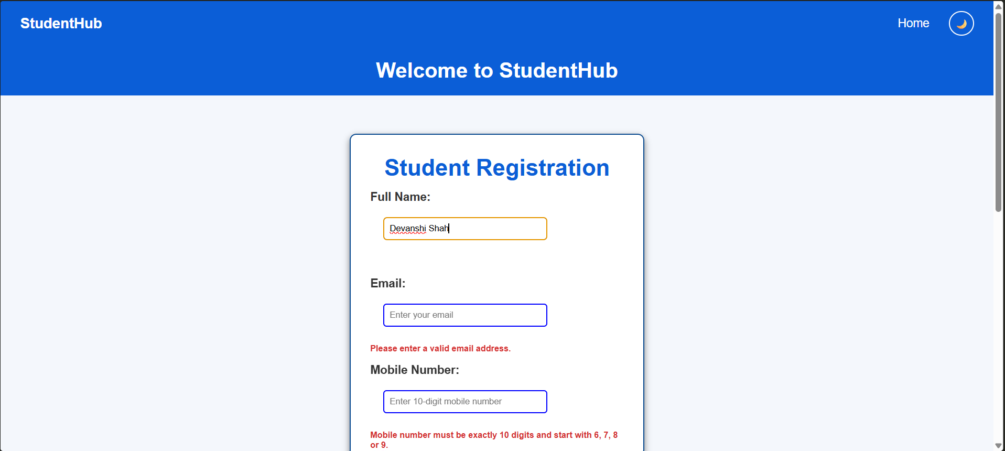
Description:
This figure shows validation for mandatory fields. Although the name and email are entered, the mobile number, course, year, and gender are not properly selected or entered. Red error messages inform the user about the missing or invalid information
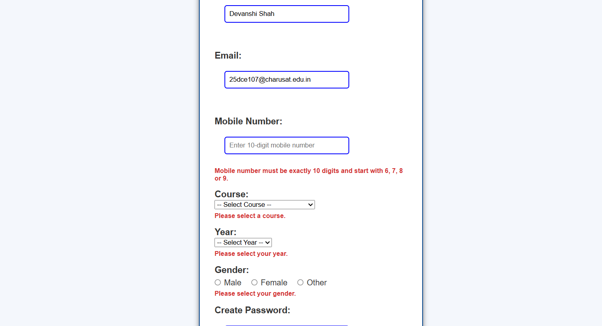
Description:
This figure shows validation for mandatory fields. Although the name and email are entered, the mobile number, course, year, and gender are not properly selected or entered. Red error messages inform the user about the missing or invalid information.
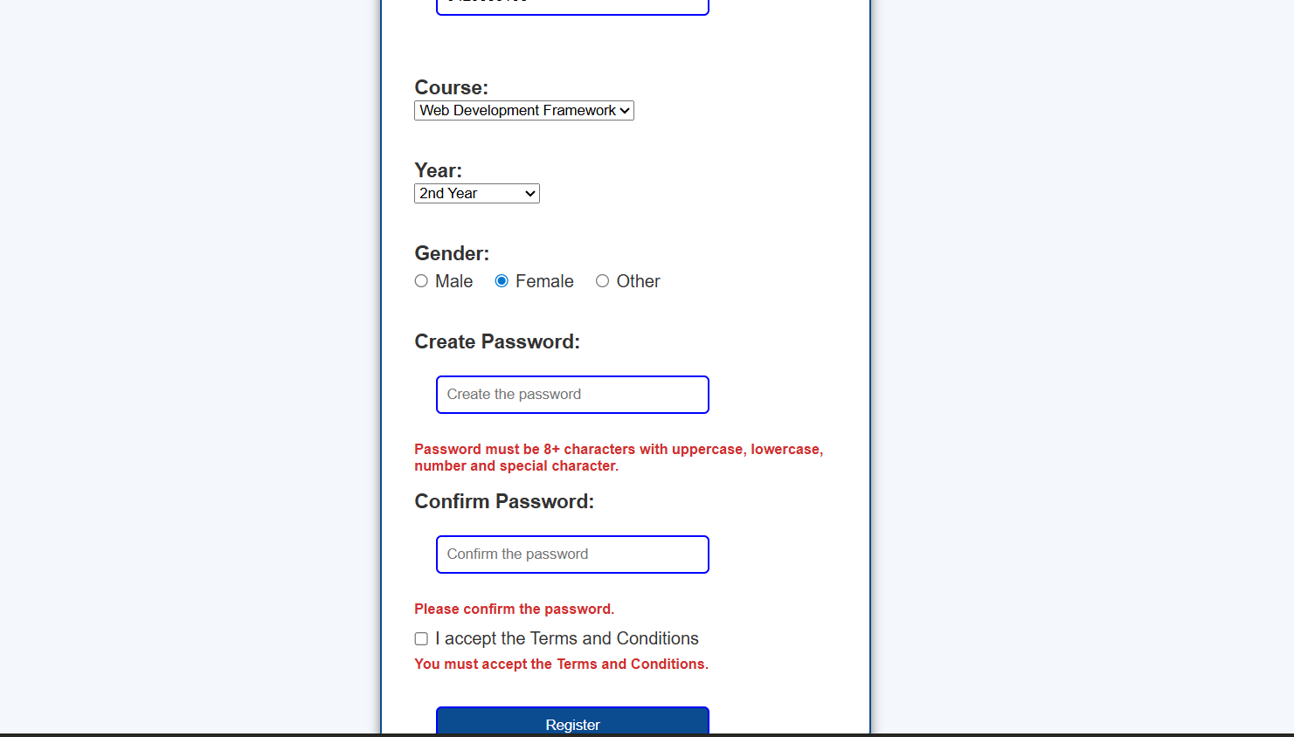
Description:
The user has selected the course, year, and gender, but the password fields and Terms & Conditions are not properly validated. The form displays messages such as:
- Password must contain at least 8 characters with uppercase, lowercase, number, and special character.
- Please confirm the password.
- You must accept the Terms and Conditions
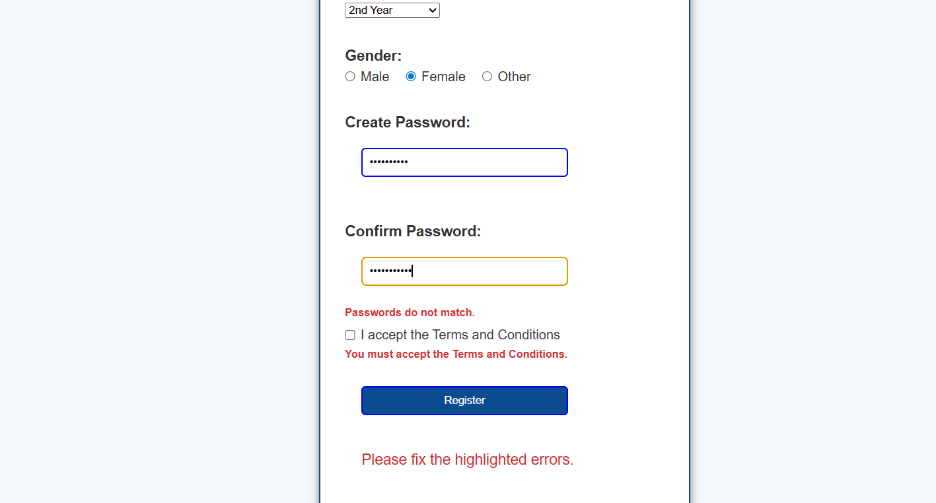
Description:
This figure shows the situation where the Password and Confirm Password fields contain different values. The system displays the error message "Passwords do not match." The Terms & Conditions checkbox is also unchecked, resulting in another validation message. A general message, "Please fix the highlighted errors," is displayed after clicking the Register button.
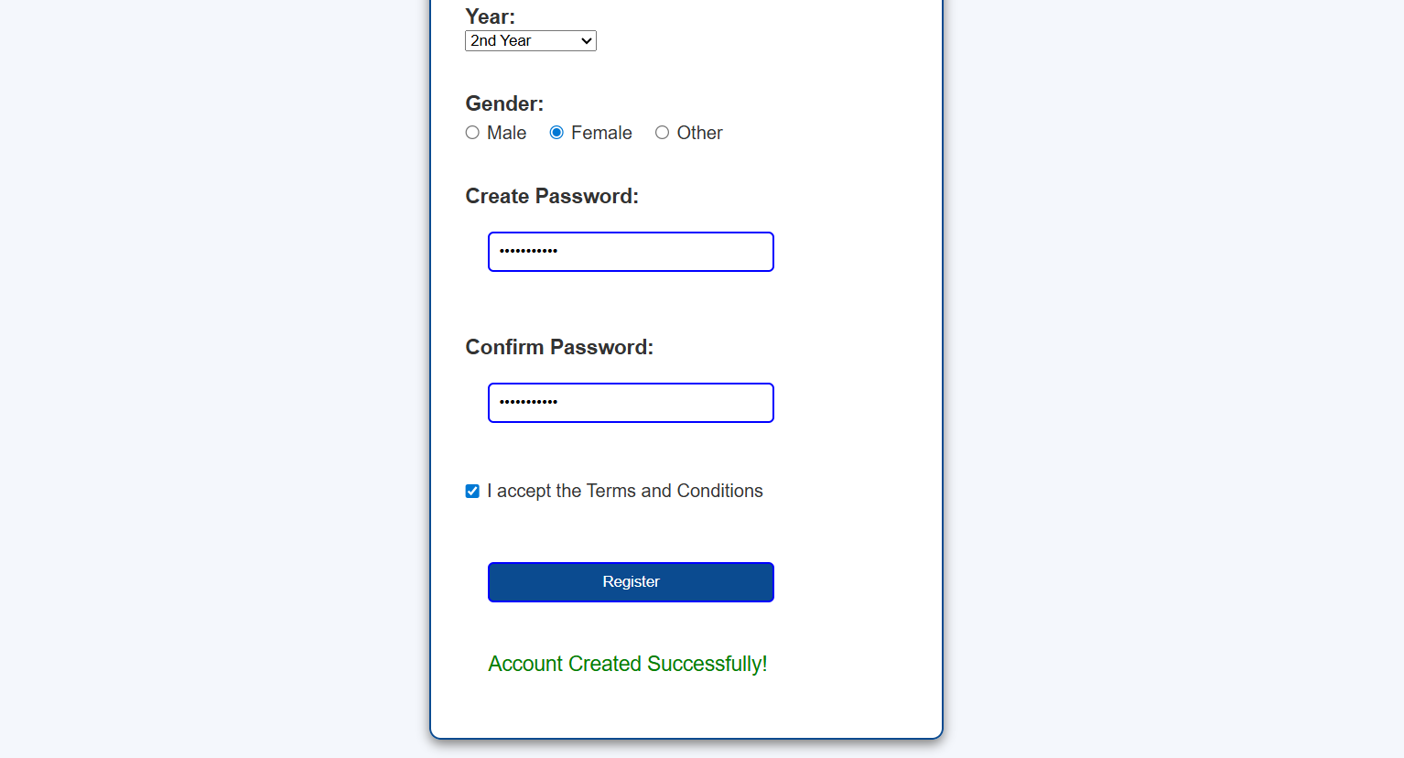

Description:
This figure shows successful form submission after all fields are correctly filled, both passwords match, and the Terms & Conditions checkbox is selected. A green success message, "Account Created Successfully!", is displayed.

GitHub Repository Link:
https://github.com/devanshirshah24-pixel/WDF-Practicals/tree/main/Practical5

Challenges Faced:

1. Regular Expression Validation
Creating correct regular expressions for name, mobile number, and password validation was challenging. The patterns had to allow valid input while rejecting invalid characters.

2. Password and Confirm Password Matching
Comparing both password fields using JavaScript and displaying an appropriate error message required careful validation logic.

3. Displaying User-Friendly Error Messages
It was challenging to show errors near the respective input fields without making the form confusing or cluttered.

4. Preventing Invalid Form Submission
JavaScript validation had to ensure that the form was submitted only when all required fields contained valid data.

5. Password Strength Implementation
Checking uppercase letters, lowercase letters, numbers, and minimum password length required multiple validation conditions.

6. Accessibility
Making the form usable through keyboard navigation and understandable by screen readers required proper use of labels, focus indicators, and semantic HTML elements.

7. Testing Different Inputs
The form needed to be tested with both valid and invalid data to ensure that every validation rule worked correctly.

Learning Outcomes:
After completing this practical, the following concepts were learned:
- HTML5 Forms
Learned how to create a student registration form using different HTML input types.
- Form Validation
Learned to validate user input using HTML attributes such as required, pattern, min, and maxlength.
- JavaScript Validation
Learned to perform client-side validation using JavaScript.
- Regular Expressions
Learned to use Regular Expressions for validating names, mobile numbers, emails, and passwords.
- Password Strength Checking
Learned how to check password complexity based on length, uppercase letters, lowercase letters, and numbers.
- Error Handling
Learned to display clear and user-friendly error messages near the corresponding fields.
- Form Accessibility
Learned the importance of labels, keyboard navigation, focus indicators, and screen-reader-friendly forms.
- Testing and Debugging
Learned to test forms using valid and invalid inputs and debug validation errors using browser developer tools.

Faculty Remarks: (Keep this blank for faculty)

